ON BEHALF OF THE JOB ASSISTER’S,

A MASSIVE THANK YOU TO ALL WHO ATTENDED YESTERDAY!

I HOPE YOU ENJOYED AS MUCH AS WE DID ☺

TO DATE WE HAVE RAISED A WHOPPING £377.74!!!

IT’S NOT OVER UNTIL THE LAST PIECE OF CAKE IS ATE!

IF YOU HURRY YOU MAY SNAP UP A FINAL NIBBLE!

☺THANK YOU☺

[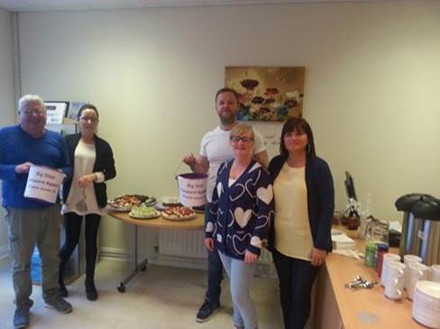](https://www.facebook.com/photo.php?fbid=839653799415379&set=a.548083628572399.1073741825.100001122998123&type=1)