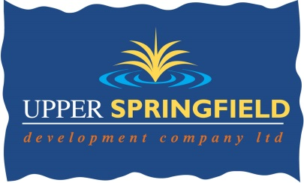

UPPER SPRINGFIELD DEVELOPMENT TRUST
PUBLIC ART IN THE COMMUNITY PROGRAMME

HAS VACANCIES FOR A BANK OF THE FOLLOWING ARTISTS

- Visual and performance artists and storytellers to facilitate programmes of workshops with groups, and to produce pieces of work for temporary public art showcases.
&
- Emerging artists who will gain mentoring support as part of the programme

WE WILL HOLD SELECTED ARTISTS DETAILS ON FILE FOR 1 YEAR FOR POTENTIAL VACANCIES. Posts are subject to funding

Artists must have skills within the following;
- Art participation skills working with a wide range of groups in the community including vulnerable young people, people with disabilities and older people.
- Temporary non-conventional sculpture
- Performance art
- Ceramics
- Construction of temporary structures
- Textiles
- Photography
- Film, video & projection
- Storytelling

Application forms and details for all of the above posts can be downloaded from www.upperspringfield.com recruitment
All completed applications, CV and images must be returned by email to: deirdre.mackel@usdt.co.uk
ARTISTS WISHING TO JOIN THE BANK MUST SUBMIT A CV WITH FULL CONTACT DETAILS OF 2 REFERENCES ALONG WITH 6 IMAGES OF ARTWORK, EACH NO BIGGER THAN 1.07 MB FROM RECENT ART PROJECTS

OUR SELECTION METHODS ARE BASED ON ARTFORMS REQUIRED FOR SPECIFIC PROJECTS
Contact: Deirdre Mackel Tel. 028 90236677
Closing date for receipt of applications:
Wednesday 19th July at 4.00pm
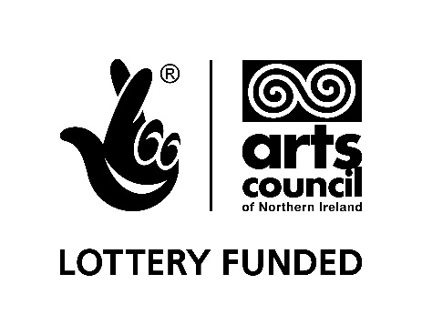

UPPER SPRINGFIELD DEVELOPMENT TRUST
APPLICATION FORM
PUBLIC ART IN THE COMMUNITY PROGRAMME
APPLICATION FOR VACANCIES FOR A BANK OF THE FOLLOWING ARTISTS
- Visual and performance artists and storytellers to facilitate programmes of workshops with groups, and producing pieces of work for temporary public art showcases.
- Emerging artists who wish to develop their art participation and engagement skills

WE WILL HOLD ARTISTS’ DETAILS ON FILE FOR 1 YEAR FOR POTENTIAL VACANCIES

Essential Criteria:
It is essential that
- The artist will demonstrate skills of making and installing or performing temporary public art/ and or/ storytelling
- The artist/s will show high innovation through examples of previous work
- The artist demonstrates skills in participation and engagement through examples of previous projects ((NB: Applicants for the post of New/Emerging Artists do not need to be scored on this section)

Desirable Criteria:
It is desirable that the artist/s will have;
- Knowledge of disadvantaged communities such as the Upper Springfield and West Belfast.
- Skills in working collaboratively with other artists. ((NB: Applicants for the post of New/Emerging Artists do not need to be scored on this section)

APPLICATION FOR THE POST OF: (Please tick)
Visual Artist □
Performance Artist □
Storyteller □
New/Emerging Artist □

Name:

Address:

Tel. No.

Qualifications(if any):

Please separately attach six electronic images, each no bigger than 1.07 MB of previous art projects, and complete the image list below, indicating, date/size/materials/location and employer/group details etc.)

NB: Applicants for New/Emerging Artists may include their individual work

Image 1:

Image 2:

Image 3:

Image 4:

Image 5:

Image 6:

Could you please indicate briefly how you meet the following before mentioned criteria
1. Skills of making and installing, or performing temporary public art and/or /storytelling
Please also list your artmaking and/or /storytelling skills

2. High innovation through examples of previous work

3. Demonstrate skills in participation and engagement through examples of previous projects
(NB: Applicants for the post of New/Emerging Artists do not need to complete this section)

4. Knowledge of disadvantaged communities such as Upper Springfield and West Belfast

5. Skills in working collaboratively with other artists.
(NB: Applicants for the post of New/Emerging Artists do not need to complete this section)

Can you provide full contact details for 2 References:

Reference 1.
Name:

Address and Postcode:

Telephone Number:

Reference 2.
Name:

Address and Postcode:

Telephone Number:

CAN YOU INDICATE ANY DATES OR TIMES OF UNAVAILABILITY FOR THE NEXT 6 MONTHS.
PLEASE NOTE: ARTISTS WILL BE REQUIRED TO WORK EVENINGS, WEEKENDS AND WEEKDAYS

Please return your completed application with images and a copy of your CV by email
To: deirdre.mackel@usdt.co.uk
Not later than 4.00 pm on Wednesday 19th July
Enquiries: Tel: 90236677

